*Streamlining Expense Approvals*

* Automated Workflow for Employee Expense Submission

**Table of Contents**

1.Introduction

2.Scenario development

1. Identifying the Business Process
2. Documenting the Problem
3. Benefits of Automation

3.Workflow Design

1. Trigger, Actions and Connectors Used
2. Steps of the Automated Workflow
3. Final Flow Design
4. Testing and Validation

4.Challenges and Solutions

5. Conclusion

**Introduction**

The Employee Expenses Submission Approval Flow simplifies and automates the process of submitting, reviewing, and approving expense requests using Microsoft Power Automate. Traditional manual methods, such as paper forms or emails, often lead to inefficiencies like delays, errors, and lack of transparency in the approval process.

This flow streamlines critical steps, including collecting expense details, routing requests for approval, and notifying employees of decisions. It saves time, improves transparency, and ensures compliance with company policies.

By integrating tools like Microsoft Forms, SharePoint, and Outlook, the flow provides an efficient and accurate expense management system that enhances productivity, transparency, and employee satisfaction.

**2.Scenario development**

1. Identifying the Business Process

The **Employee Expense Submission and Approval Process** involves employees submitting expense reports for business-related costs, such as travel or office supplies, to managers or finance teams for review. Currently, this manual process requires employees to complete forms, attach receipts, and send them via email, with managers conducting time-consuming and error-prone reviews.

**Key Elements of the Process**:

1. Submission of expense details, including receipts, descriptions, and amounts.
2. Review of submissions by approvers to ensure they meet company policies.
3. Approval or rejection of expenses, with feedback provided to employees.
4. Status updates to ensure transparency and timely reimbursements.
5. Documenting the Problem

The manual process presents challenges, including inefficiency, as handling multiple expense statements manually can lead to delays, especially when approvers are overwhelmed with requests.

**Errors and Omissions**: Employees may become frustrated, and managers may have to do more follow-up work if receipts are misplaced, or incomplete forms are submitted.

**Lack of Transparency**: Employees frequently do not have access to the status of their submissions, which causes them to repeatedly ask questions and causes compensation delays.

**Limited Tracking and Records**: It is challenging to keep an organized record of approved or denied expenses for reporting or audits while using manual techniques.

1. Benefits of Automation

Automating the expense submission and approval process using **Power Automate** resolves these issues, delivering several benefits:

**Streamlined Approval Process**:

Approvals are routed to the appropriate supervisors based on predefined guidelines, ensuring timely and accurate evaluations while avoiding delays.

**Enhanced Transparency**:

The status of every submission is communicated in real time to approvers and staff.  
Every comment and approval is recorded in a centralized system in SharePoint.

**Error Reduction**:

Validation steps are included in the flow to ensure all necessary fields—like attaching receipts and inputting spending amounts—are filled out correct.

**Improved Efficiency**:

Automation eliminates manual record-keeping and email follow-ups, allowing employees to save time by submitting expenses through a standardized form.

Businesses may enhance employee satisfaction, minimize errors, and save time by automating the cost clearance process.

**3.Workflow Design**

1. Trigger, Actions and Connectors Used

* Trigger

A **trigger** in Power Automate is an event that starts a workflow or flow. It acts as the initiating point, telling the system when to run the automated process.

The Microsoft Forms trigger "**When a new response is submitted"** starts the flow.

Whenever an employee uses the Form to submit a new expense report, this trigger starts the flow.

* + Actions

**1.Get Response Details**:

Retrieves the information that the employee entered into the Microsoft Form.

Assures that all expense information is available for additional processing.

**2.Condition:**

Evaluates criteria such as amount limits and approvals, ensuring expenses are validated before being approved by relevant authorities**.**

**3.Start and Wait for an Approval:**

Evaluates criteria such as amount limits and approvals, ensuring expenses are validated before being approved by relevant authorities.

**4.Send an Email (Outlook):**

Sends notification emails to employees and approvers about the submission status, ensuring all stakeholders are informed and transparency is maintained.

**5.Update Item (SharePoint):**

Updates the approval status of the expense report in the Employee Submission list (Approved, Rejected), providing a centralized, real-time tracking system for all submissions.

.

* + Connectors Used

1. **Microsoft Forms:**

Collects expense submission details from employees

1. **SharePoint:**

stores and updates the expense data, creating a centralized platform to record all submissions.

1. **Outlook:**

Sends emails for notifications, approvals status, and feedback

1. **Approvals:**

Manages the approval requests sent to managers or the finance team

1. **SharePoint:**

Stores request submission, approval status and files uploaded during the submission process

II. Steps of the Automated Workflow

**1.Create a form to collect employee expenses submission details.**

Microsoft Forms is a versatile tool for creating forms, surveys, quizzes, and polls, primarily used to collect data efficiently and securely.

1.log into Microsoft forms

2.Select create a form

**Link to the Employee leave submission form**

<https://forms.office.com/r/LhGJ0tfc6Q?origin=lprLink>

The employee is asked nine questions on the form to gather the necessary information for the approval process.

|  |  |  |
| --- | --- | --- |
| Question Name | Type | Description |
| Employee Name | Text | Name of the employee |
| Email Address | Text | Company Email address of the employee |
| Department | Choice | The Department of the employee |
| Date | Date and Time | The date of the expenses form submission |
| Type of expense | Choice | Travel, Meals and Entertainment, Office Supplies and Equipment, Training and Development, Professional Fees |
| Amount | Text  Added restrictions to only ad a number | The expected amount |
| Description | Text | Description of the expense |
| Attachments | Upload a file | Attach relevant files if available |
| Approval status | Choice | Status of the approval  Set to Pending |

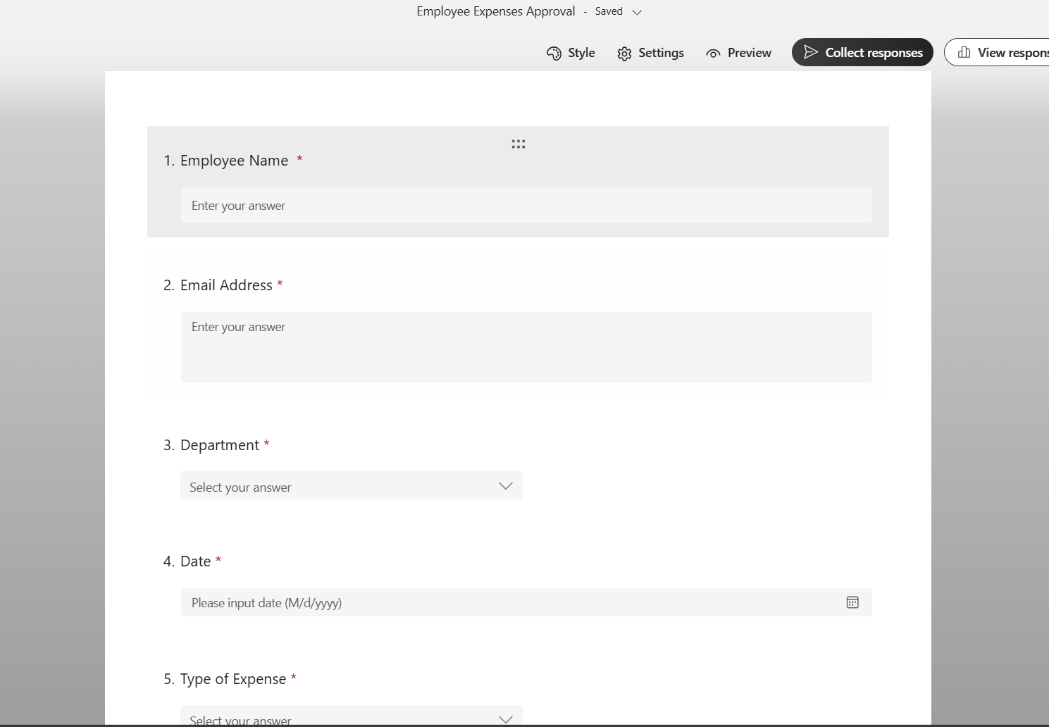

**2.Share point list creation**

1.Log in to the share point

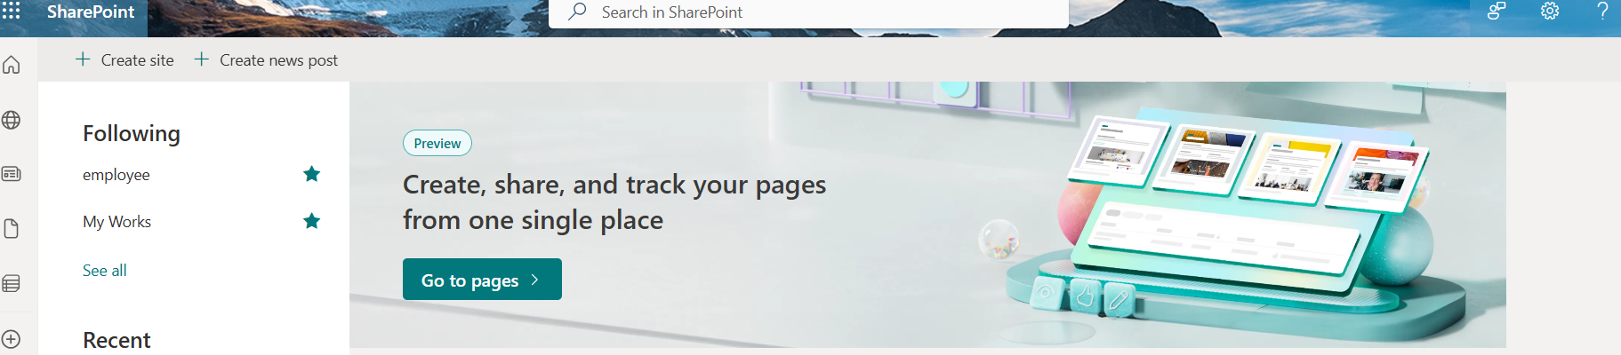

2.From the Icon in the top left corner (+) create a site

Create a SharePoint site named **Employee** to serve as a centralized platform for managing and collaborating on information, documents, and workflows within the organization.

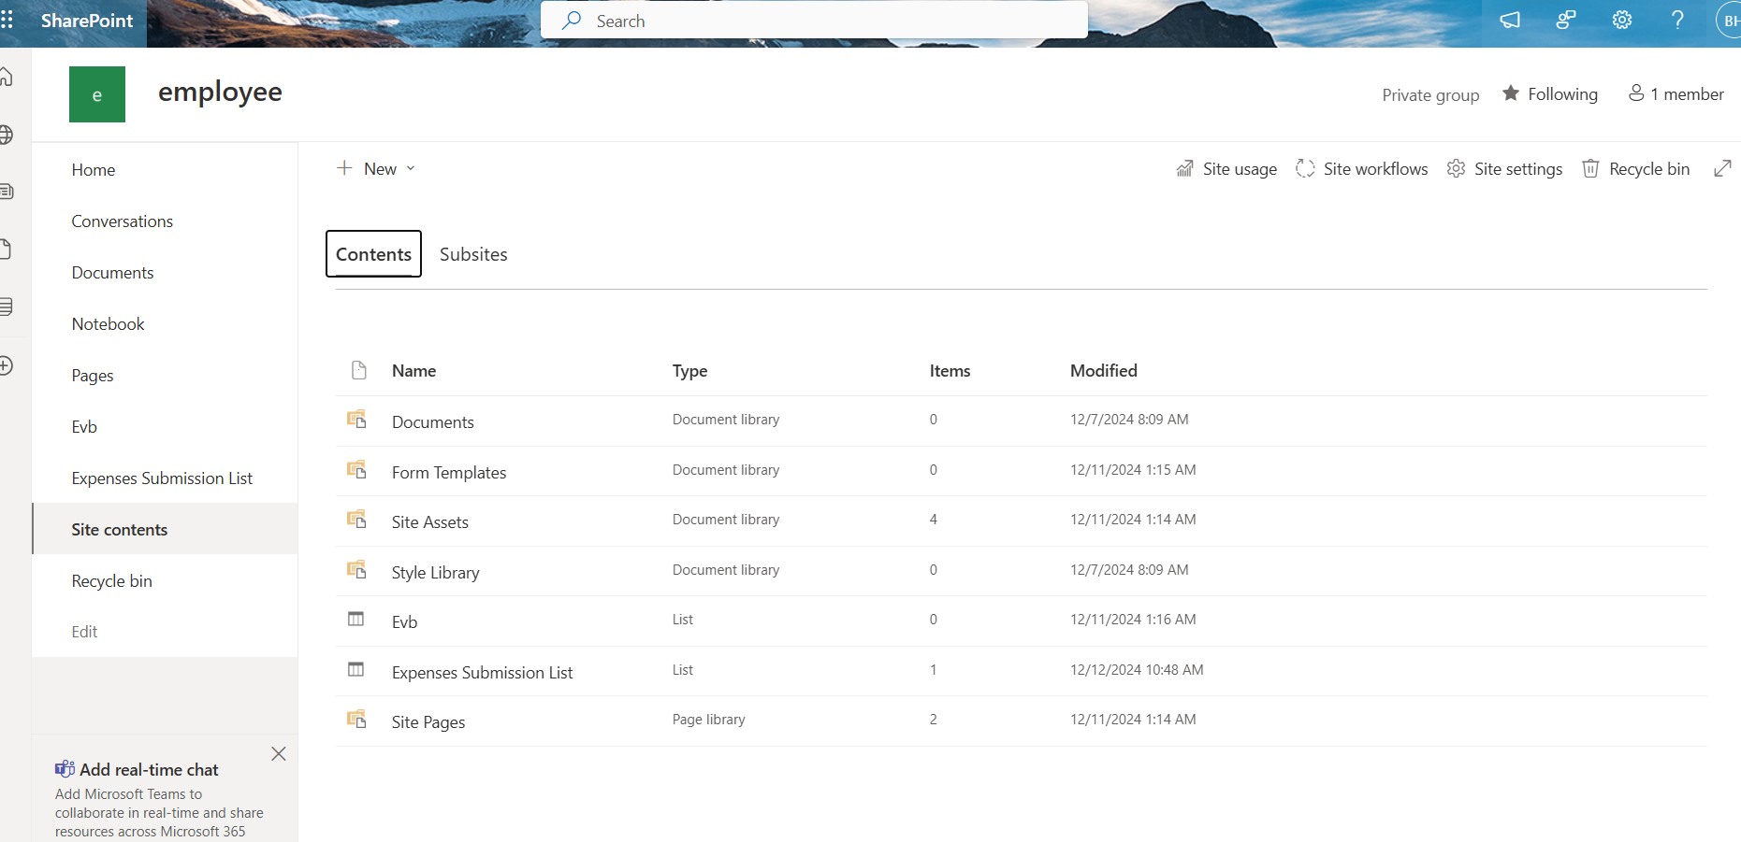

3.Inside the employee site select the (+ New) icon and create a list.

The **Expenses Submission List** stores details from the **Employee Expenses Submission Form** in SharePoint, offering a collaborative and organized way to manage structured data.

4. Choose "Add Column" to add columns for storing input details.

5. Several columns are created in relation to the information entered into the Employee Expenses Submission Form.

Columns:

The title column here is a default column that included in a every list

Column names

|  |  |  |  |  |  |  |  |  |  |  |  |  |  |  |  |  |  |  |  |  |  |  |  |  |
| --- | --- | --- | --- | --- | --- | --- | --- | --- | --- | --- | --- | --- | --- | --- | --- | --- | --- | --- | --- | --- | --- | --- | --- | --- |
| |  |  |  | | --- | --- | --- | | Column names | Type | Description | | 1.Employee Name | Text | Names Employee | | 2.Email Address | Text | Email Address of Employees | | 3.Department | Choice  Choices:  (HR, IT, Finance, Sales, Marketing) | The Department of the Employee | | 4.Date | Date and Time | The date of the expenses form  submitted | | 5.Amount | Text | The Amount Expected | | 6.Description | Text | Description of the Expense | | 7.Approval Status | Choice  Choices:  (Pending, Approved, Rejected) | The Status of the Approval | |

* **The Amount column is set to text format, as the form's "requested amount" question is a text field with a number restriction. Using a number column type would cause incorrect data saving.**
* **The default approval status is set to Pending, and the status automatically updates to Approved or Rejected after the relevant authority makes a decision.**

**3.Power Automate flow creation**

1.Log into the power automate using organizational login credentials

2.Select the (+) create button

3.Select automated cloud flow

An **Automated Cloud Flow** in Power Automate triggers actions automatically, starting when an employee submits an **Expense Request Form**.

4.Enter the flow name

The flow name is **Employee Expenses Submission Approval Flow**

5.Choose the flow’s trigger

A **trigger** in Power Automate starts a workflow based on specific events or conditions. Without it, a flow cannot run. The **Microsoft Forms trigger** "When a new response is submitted" starts the flow when an employee submits the expense form.

Select **Create** to initiate the flow.

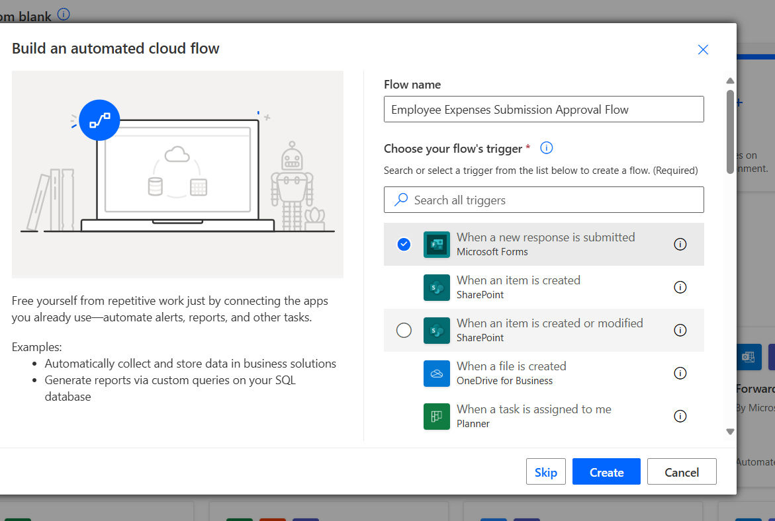

6.Input parameters

After creating the flow trigger, sign in to Microsoft Forms to connect to the **Employee Expenses Submission Approval** form. Rename it to **Input Expense Form Details** for identification. Select the form name under the **Form ID**.

7.Add an action

An **action** in Power Automate is a specific task or operation that the flow performs after it is triggered. Actions define what the flow does,

8.Select get response details action

Rename **Get Response Details** to **Get Expenses Form Details**. Select the **Employee Expenses Approval** form under **Form ID**. Then, choose the **Response ID** from **Dynamic Content**, which uniquely identifies each response for processing.

9.Add create a item action

Rename **Create an Item** to **Store Expenses Details in a List**.  
Sign in to **Microsoft SharePoint** using login credentials to connect to the **Employee Submission List**.  
Select the **Employee Site Address** for **Site Address** and **Expenses Submission List** for **List Name**.  
Use **Dynamic Content** to map the form response data to the corresponding columns in the SharePoint list.

8.Add condition Action

A **Condition** in Power Automate is a control action that creates a decision-making step, allowing the flow to take different actions based on whether a condition is true or false.

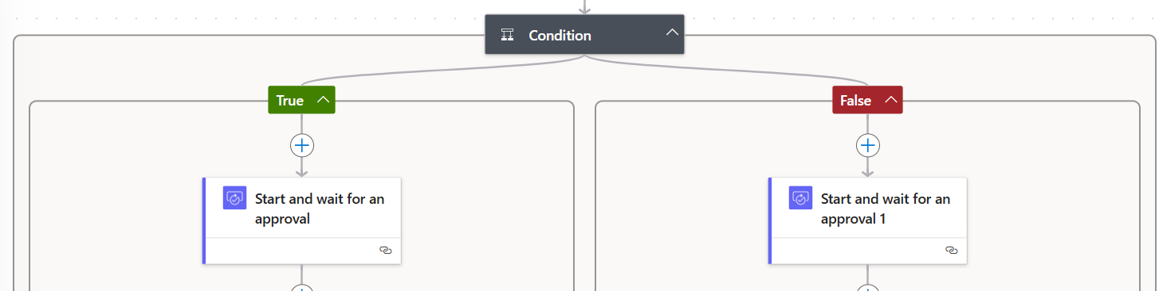

Set the condition to check if the employee's requested amount is greater than 50,000:

* **Left-hand side**: Use the expression int (Amount) from **Get Response Details**.
* **Operator**: Choose **greater than**.
* **Right-hand side**: Set the value to **50000**.

If true, send the request to the senior manager; if false, route it to the financial accountant.

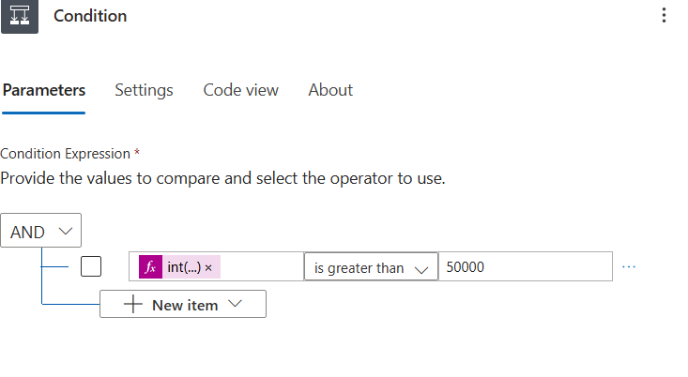

If the condition is TRUE

9.Add an approval action

An **Approval** action sends a request to the senior manager to approve or reject. The flow continues based on their decision.

* **Approval type**: First to respond
* **Title**: Expenses submission for approval
* **Assigned To**: Add the approver's email
* **Details**: Include employee department, total amount, category, and submission date from the form.

10.Add a condition action to check whether the submission is approved or rejected by the senior manager

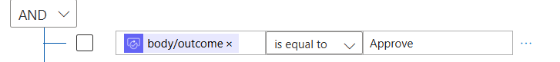

Check if the approval outcome is Approve

If the outcome is TRUE or FALSE

**In TRUE status,**

11.Add an action Send an email(V2) in the action panel to notify the Employee

Log in to Outlook with the necessary credentials.

* In Power Automate, search for **"Send an email"** in the action panel.
* Select **Outlook (Send an email v2)** for Microsoft 365 or Office 365 accounts.

**To**: Enter the employee's email address.  
**Subject**: Write a clear subject line.  
**Body**: Add email content and use **Dynamic Content** to personalize it based on the form submission details.

12.Add Update item action

To modify the approval item in the **Employee Submission List**:

* **Site Address**: Select the SharePoint employee site.
* **List Name**: Choose the **Employee Submission List**.
* **ID**: Select the **Response ID** to identify the item.
* **Fields to Update**: Update the **Approval Status** from **Pending** to **Approved** or **Rejected** based on the approval outcome.

In the **FALSE** status if the financial manager rejects the approval

13.Use the Update Item action

14.Add send an email action to notify the employee about rejection.

Subject- about rejection

Body- Change body details according to the rejection.

If the employee's requested amount is less than 50,000, send the request to the **financial accountant** to proceed with the approval.

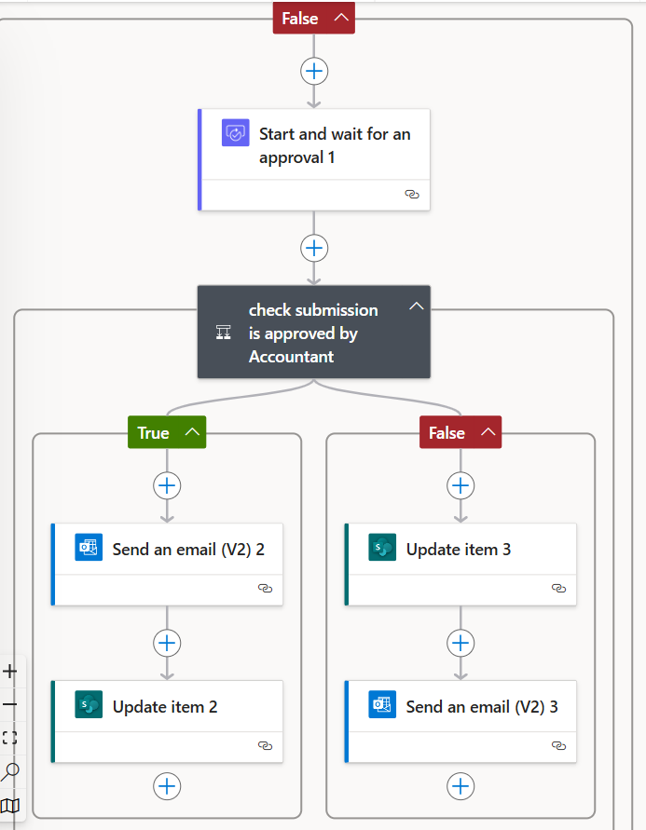

15.Add approval action in the panel to proceed with approval from the financial accountant.

For the Assigned to add the email address of the Financial Accountant.

15.Add a condition to check for the outcome of the approval

If the condition is True that the submission is a**pproved** by the financial accountant

Add a action send email(v2) to notify the employee.

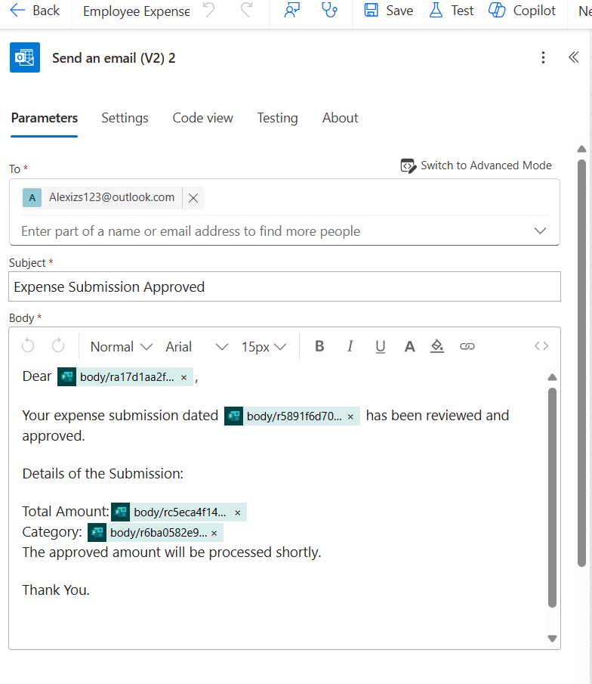16.Add a condition Update item to Update the status of the approval.

If the outcome of the condition is false that the Submission is rejected by the Approver,

17.Add update item action

Update the status of the Approval in the employee submission list as Rejected

18.Add a action send an email (v2)

To notify the employee about rejection (send an email(v2)) action.

III.Final Flow Design

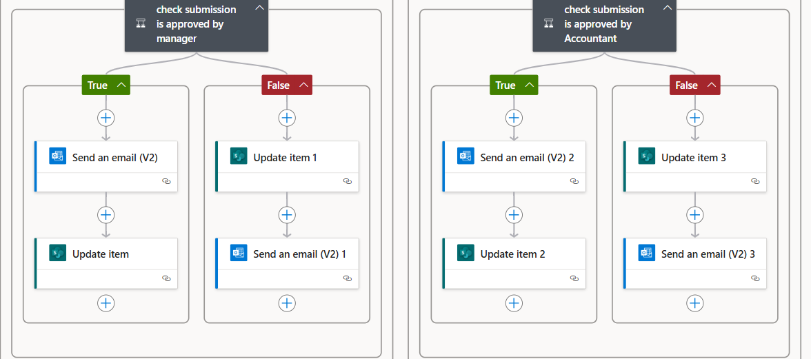

IV. Testing and Validation



1.To test the flow, select Test icon in the upper right corner of the automate





2.Then select Manually, Save &Test

3.The process begins when an employee submits an expense report via **Microsoft Forms**



Link to the form: <https://forms.office.com/r/LhGJ0tfc6Q?origin=lprLink>

4. A confirmation message is sent to the employee after the submission to acknowledge receipt of their expense request.

5.The flow retrieves the details from the form and updated in the Employee submission List

6.The approval status set to pending until the approver Approve/Reject the request





7.The flow checks if the total requested amount is greater than or less than Rs. 50,000.

If the amount is greater, the request is sent to the **Finance Manager**; if less, it goes to the **Financial Accountant**.

The flow sends the expense report to the designated approver via **Outlook** or **Teams**.  
The approver reviews the details and either:

* **Approve**: If the expense meets company policies and is complete.
* **Reject**: If the expense does not meet guidelines or needs corrections.

8. The flow notifies the approver about the final approval status via **Outlook** and **Teams**.

Flow checks the approval outcome by a condition to proceed with the next steps.

**If Approved**:

9. The flow updates the approval status in the **expenses submission list** to **"Approved"**.



10.An email notification is sent to the employee, confirming approval.

**If Rejected**:

12.The flow updates the approval status in the **expenses submission list** to **"Rejected"**.



13.An email notification is sent to the employee with the rejection reason and any additional comments.

14.The message will appear in the automate flow after the flow executed successfully.



4.Challenges and Solutions

I. Triggering the flow correctly  
The flow may not trigger if configurations or permissions are incorrect.  
Solution: Ensures the correct trigger ("When a new response is submitted") is set and all

II. Mapping dynamic content correctly  
Data may not map correctly to SharePoint or other apps, leading to missing or incorrect information.  
Solution: Used **Dynamic Content** to map fields accurately and test the flow to ensure all fields, like amounts, dates, and categories, are properly mapped.

III.Handling multiple approvers

Managing multiple approvers can be complex.

**Solution**: Use conditional actions or parallel branches to route approvals based on criteria.

IV.Ensuring accurate approval status updates

Approval status may not update correctly.

**Solution**: Use **Update Item** action after approval to ensure the status is updated in SharePoint.

V.Managing notifications

Notification emails or messages may be incorrectly formatted.

**Solution**: Use **Dynamic Content** to personalize and ensure accurate information in notifications

5. Conclusion

The Employee Expenses Submission and Approval Flow automates and streamlines the expense process using Power Automate, Microsoft Forms, SharePoint, and Outlook. It enhances efficiency, reduces errors, and improves transparency. Challenges like handling multiple approvers and mapping dynamic content can be resolved through proper configuration and testing.

The flow speeds up approval times, ensures policy compliance, and creates a more efficient, user-friendly expense management system for the organization.